Pre questionnaire: General advice 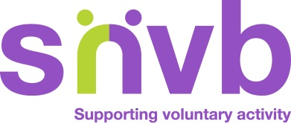
Be aware that, as an snvb client, you agree that we hold certain personal details about you. These are stored securely and used only in connection with providing this service to you personally. We encourage you to subscribe to our database so that we can send you news and information about all of our services from time to time. You can do this by clicking the link on any page of our website. Details of our privacy policy can be provided to you on request.

Providing the information to us on this form will give our adviser an overview of your needs and allow them to be well prepared to discuss all of your questions.

Name: | Organisation:
Address: | Telephone Number
Email:

Please outline your query below

Do you need any volunteers for your project?

Please email your completed form to jeanette@snvb.org.uk

